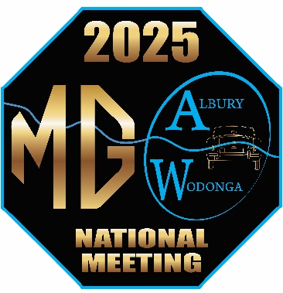

EXPRESSION OF INTEREST - ACCOMMODATION
2025 ALBURY/WODONGA MG NATIONAL MEETING

Please click the checkbox to indicate your accommodation preference.
☐Motel Room Single – Albury City Centre
☐Motel Room Double – Albury City Centre
☐Motel Room Single with trailer parking – Albury City Centre
☐Motel Room Double with trailer parking – Albury City Centre
☐Caravan Park – Cabin with parking for car and trailer
☐Caravan Park – powered site with parking for van, car and trailer.
NB – Air B and B will need to be booked by individual entrants.
Name/s: Ph: (mobile preferred)
Email address:

Leigh Albertson (joint co-ordinator) Sandra Cardnell (joint co-ordinator)
ljalbertson@live.com.au 0478 272 592 cardnellis@bigpond.com 0419 169 540
After indicating your choice, please email (as an attachment) to Leigh or Sandra.
NB: We have listed Albury for motels because it’s a town with more historical buildings, but there are motel choices in Wodonga.
If you are unable to add your accommodation preference and details to Word Document, please provide them via email.
Note this is important for us to able to determine group booking opportunities.
PLEASE REPLY VIA EMAIL BY 8 JULY

